Chapter 1: Information Systems in Global Business Today

學習目標 :

* 1. 資訊系統如何改變商業，它們與全球化的關係是什麼？為什麼資訊系統對於當今經營和管理企業(business)如此重要？
  2. 資訊系統到底是什麼？它是如何運作的？它的管理、組織和技術所的元件(components)是什麼？什麼是互補性資(complementary asset)？為什麼互補性資產(complementary asset)對於確保資訊系統為組織提供真正的價值至關重要？
  3. 哪些學科(academic disciplines)用於研究資訊系統？它們各自如何有助於對資訊系統的認識？
* Rugby Football Union Tries Big Data

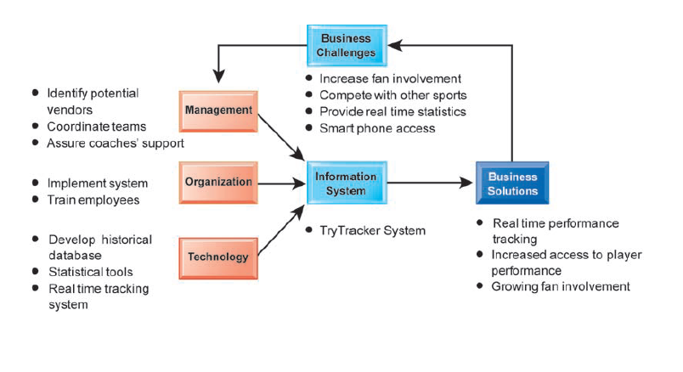

* Problem: Improving fan engagement through Big Data.
* Solutions:
* Provide data visualization and real-time statistics to draw in fans.
* Provide tactical insights to players and coaches that will improve match play.

1. **THE ROLE OF INFORMATION SYSTEMS IN BUSINESS TODAY**
   * Preface

* most of the business value of IT investment derives from these organizational, management, and cultural changes inside firms
* between 2005 and 2015, global investment in information technology

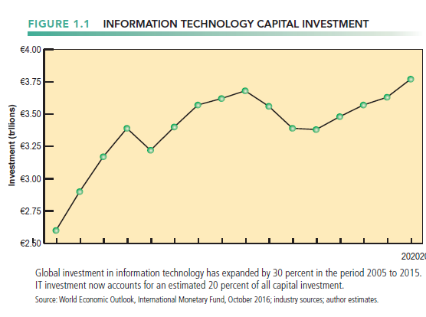

* + How information systems are transforming business
* Emerging mobile digital platform
* Some 2.8 billion people worldwide have smartphones
* phones and tablets are the primary means of access to the Internet.
* Smartphones, social networking, texting, e-mailing, and webinars have all become essential tools of business
* In 2016 1.62 billion Internet users will purchase online, generating $1.9 billion in sales. Half of these sales will be from mobile devices
* An estimated 1.7 billion people watch videos and feature films online, 100 million post to a blog everyday, and 250 million read a blog
* Social networking site Facebook attracted more than 1.7 billion monthly visitors worldwide
* Growing business use of “big data”
* Businesses are using information technology to sense and respond to rapidly changing customer demand, reduce inventories to the lowest possible levels, and achieve higher levels of operational efficiency.
* Global e-commerce and Internet advertising continue to expand.
* the value of information flowing between countries has grown 45 times since 2005
* These changes in information technology and systems, consumer behavior, and commerce have spurred the annual growth of digital information to over 5 **exabytes** every few days, roughly equivalent to all the libraries in existence
  + What’s New in Management Information Systems
* IT Innovations
* A continuing stream of information technology innovations is transforming the traditional business world.
* Examples
  + - * + cloud computing, the growth of a mobile digital business platform, big data, business analytics, the use of social networks by managers to achieve business objectives.
* New Business Models.
* the emergence of online video services
  + - * + Netflix (Internet TV revolution), Apple iTunes, Amazon
* E-commerce Expanding
* generated about $600 billion in revenues in 2016 and is estimated to grow to nearly $900 billion by 2020.
* changing how firms design, produce, and deliver their products and services
* Information systems and technologies are the foundation of this new services-based e-commerce.
* Management Changes
* salespeople on the road are only seconds away from their managers’ questions and oversight
* Business is going mobile, along with consumers.
* Managers on the move are in direct, continuous contact with their employees
* managers no longer operate in a fog of confusion but instead have online, nearly instant access to the really important information they need for accurate and timely decisions.
* wikis and blogs are becoming important corporate tools for communication, collaboration, and information sharing.
* Changes in Firms and Organizations
* put less emphasis on hierarchy and structure and more emphasis on employees taking on multiple roles and tasks and collaborating with others on a team.
* emphasize higher speed and more accurate decision making based on data and analysis.
* use social media to enter into conversations with consumers and demonstrate a greater willingness to listen to consumers
  + GLOBALIZATION CHALLENGES AND OPPORTUNITIES:

A FLATTENED WORLD

* Drastic reduction of costs of operating and transacting on global scale
* Competition for jobs, markets, resources, ideas
* Dependence on imports and exports
* Requires new understandings of skills, markets, opportunities
* Increases in foreign trade, outsourcing
* Presents both challenges and opportunities
* Information systems enable globalization.
  + THE EMERGING DIGITAL FIRM
* **Digital firm**
* significant business relationships with customers, suppliers, and employees are digitally enabled and mediated.
* Core business processes are accomplished through digital networks
  + - * + Business processes refer to the set of logically related tasks and behaviors that organizations develop over time to produce specific business results and the unique manner in which these activities are organized and coordinated.
* Key corporate—intellectual property, core competencies, and financial and human assets assets are managed digitally.
* Digital firms offer greater flexibility in organization and management.
* **Time shifting** refers to business being conducted continuously, 24/7, rather than in narrow “work day” time bands of 9 a.m. to 5 p.m.
* **Space shifting** means that work takes place in a global workshop, as well as within national boundaries.
  + STRATEGIC BUSINESS OBJECTIVES OF INFORMATION SYSTEMS
* Growing interdependence between
* Ability to use information technology
* Ability to implement corporate strategies and achieve corporate goals

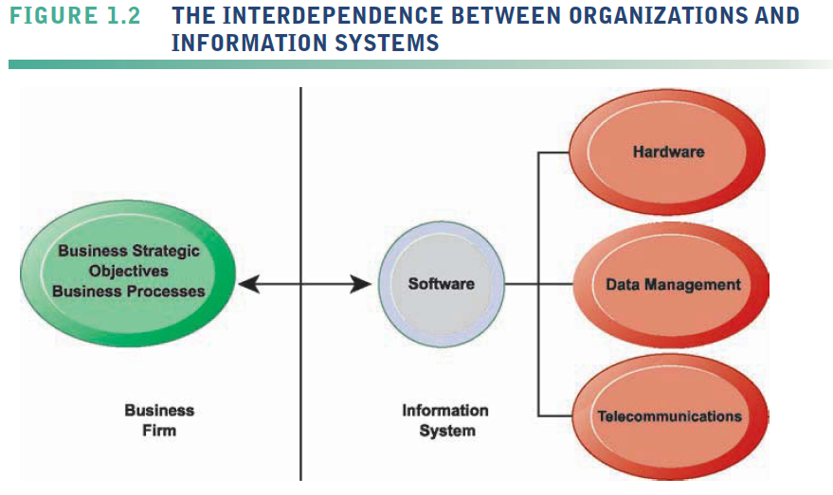

* Businesses invest in IT to achieve six important business objectives:

1. Operational excellence

* Improvement of efficiency to attain higher profitability
* Information systems, technology an important tool in achieving greater efficiency and productivity
* Example: Walmart
  + - Retail Link system links suppliers to stores for superior replenishment system

1. New products, services, and business models

* **Business model:** how a company produces, delivers, and sells its products and services
* Information systems and technology a major enabling tool for new products, services, business models
* Example: Apple
  + - Transformed old model of music distribution with iTunes.
    - Constant innovations—iPod, iPhone, iPad, and so on.

1. Customer and supplier intimacy

* Serving customers well leads to customers returning, which raises revenues and profits.
  + - High-end hotels that use computers to track customer preferences and used to monitor and customize environment
* Close relationships with suppliers result in lower costs.
  + - JCPenney : IT to enhance relationship with supplier in Hong Kong

1. Improved decision making

* If managers rely on forecasts, best guesses, and luck,
  + - Overproduction, underproduction
    - Misallocation of resources
    - Poor response times
* Real-time data improves ability of managers to make decisions.
* Example : Verizon
  + - Web-based digital dashboard to update managers with real-time data on customer complaints, network performance, and line outages

1. Competitive advantage

* Delivering better performance
* Charging less for superior products
* Responding to customers and suppliers in real time
* Examples
  + - Apple, Walmart, UPS

1. Survival

* Information technologies as necessity of business.
* Keeping up with competitors(Industry-level changes)
  + - Citibank’s introduction of ATMs
* Governmental regulations requiring record-keeping
  + - Toxic Substances Control Act and the Sarbanes-Oxley Act
    - Dodd-Frank Act

1. PERSPECTIVES ON INFORMATION SYSTEMS
   * Preface

* **Information technology (IT) :** consists of all the hardware and software that a firm needs to use in order to achieve its business objectives.
  + What Is an Information System?
* **Information system** can be defined technically as a set of interrelated components :
  + - collect (or retrieve), process, store, and distribute information
    - support decision making, control.
    - Help with analysis, visualization, and product creation.
    - contain information about significant people, places, and things within the organization or in the environment surrounding it.
* Information vs. data
* **Information** : data shaped into meaningful, useful form.
* **Data** : streams of raw facts.

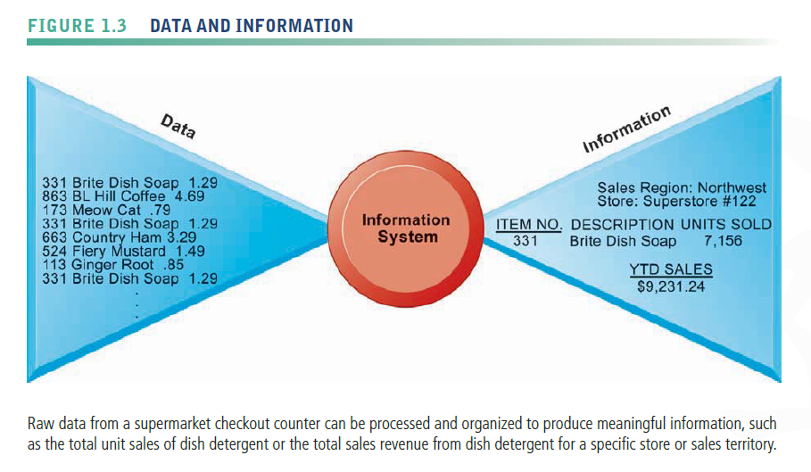

* Activities in an information system that produce information:

1. Input
   * + captures or collects raw data from within the organization or from its external environment
2. Processing
   * + converts this raw input into a meaningful form.
3. Output
   * + transfers the processed information to the people who will use it or to the activities for which it will be used.

* Feedback
  + - return to appropriate members of the organization to help them evaluate or correct the

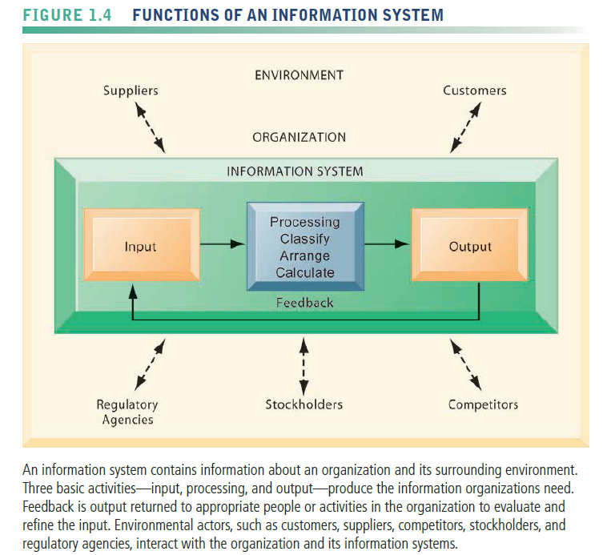input stage.

* Computer/computer program vs. information system
  + - Computers provide the equipment for storing and processing information
    - Computer programs, or software, are sets of operating instructions that direct and control computer processing
    - Computer/computer program vs. information system
  + DIMENSIONS OF INFORMATION SYSTEMS
* Preface
* Information systems literacy
  + - * + understanding of the management and organizational dimensions of systems as well as the technical dimensions of systems.
* Computer literacy
  + - * + Focuses mostly on knowledge of IT
* Management information systems (MIS)
  + - * + Focuses on broader information systems literacy
        + deals with behavioral technical issues surrounding development, use, and impact of information systems used by managers and employees

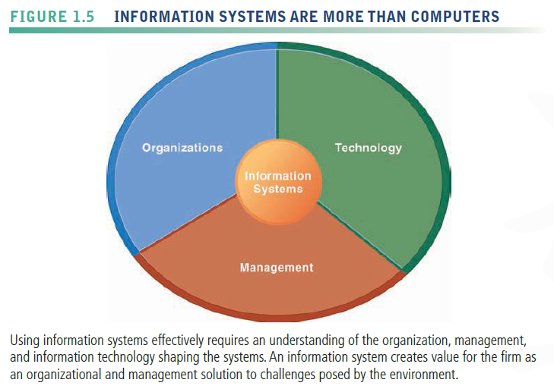

* Organizations
  + - Information systems are an integral part of organizations
    - Hierarchy of authority, responsibility.

1. Senior management : makes long-range strategic decisions about products and services as well as ensures financial performance of the firm.
2. Middle management : carries out the programs and plans of senior management
3. Knowledge workers : such as engineers, scientists, or

architects, design products or services and create new knowledge for the firm.

1. operational management : monitoring the daily activities of the business.
2. data workers : such as secretaries or clerks, assist with scheduling and communications at all levels of the firm.
3. Production or service workers : actually produce the product and deliver the service.

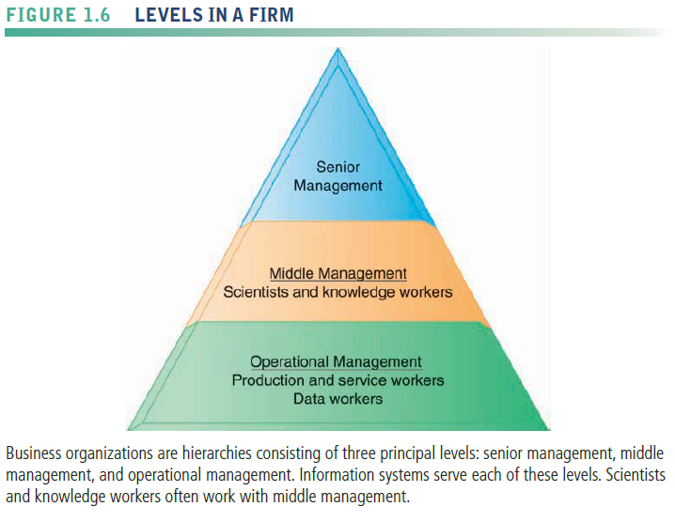

* + - The major business functions, or specialized tasks performed by business organizations, consist of sales and marketing, manufacturing and production, finance and accounting, and human resources

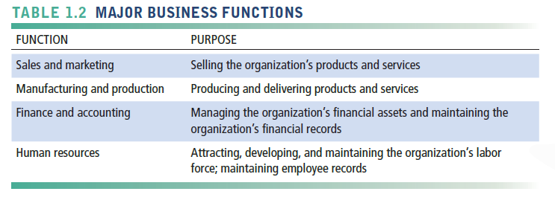

* + - Unique business processes
      * + Most organizations’ business processes include formal rules that have been developed over a long time for accomplishing tasks.
        + Rules guide employees in a variety of procedures, from writing an invoice to responding to customer complaints
        + Some of these business processes have been written down, but others are informal work practices
        + Information systems automate many business processes.
    - Unique business culture
      * + has a unique culture , or fundamental set of assumptions, values, and ways of doing things, that has been accepted by most of its members.
    - Culture embedded in information system
* Example: UPS’s concern with placing service to customer first.
  + - Organizational politics
* Conflict is the basis for organizational politics
* Management
  + - make sense out of the many situations faced by organizations, make decisions, and formulate action plans to solve organizational problems.
    - managers must act creatively
* Creation of new products and services
* Occasionally re-creating the organization
  + - Information technology helping managers design and deliver new products and services and redirecting and redesigning their organizations
* Information Technology
* Information technology is one of many tools managers use to cope with change.
* IT Infrastructure
* provides platform that system is built on

1. Computer hardware
2. Computer software
3. Data management technology : software governing the organization of data on physical storage media.
4. Networking and telecommunications technology : Internet and Web, extranets, intranets, Voice, video communications.
   * + Instance : Dimensions of UPS tracking system
       - * Organizational - Procedures for tracking packages and managing inventory and provide information
         * Management - Monitor service levels and costs
         * Technology - Handheld computers, bar-code scanners, networks, desktop computers, and so on
   * IT Isn’t Just Technology: A Business Perspective on Information Systems

* Information system is instrument for creating value
* Investments in information technology will result in superior returns
  + - Productivity increases
    - Revenue increases
    - Superior long-term strategic positioning
* Every business has an information value chain
* Raw data acquired and transformed through stages that add value to that information
* Value of information system determined in part by extent to which it leads to better decisions, greater efficiency, and higher profits

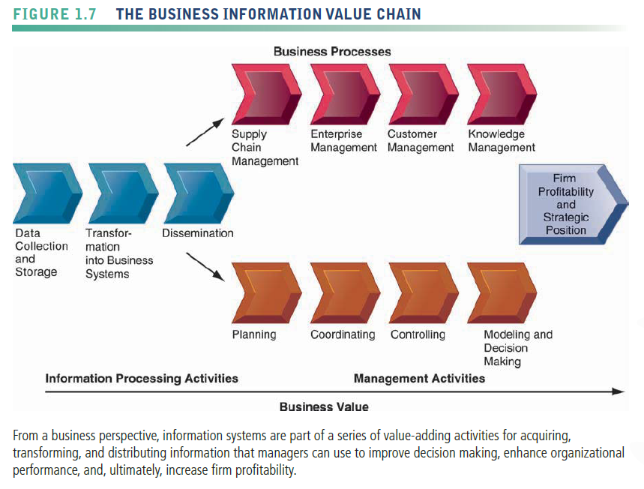

* represents an organizational and management solution, based on information technology, to a challenge or problem posed by the environment.
* Business perspective
* Calls attention to organizational and managerial nature of information systems
* an organizational and management solution, based on information technology, to a challenge or problem posed by the environment.
  + COMPLEMENTARY ASSETS: ORGANIZATIONAL CAPITAL AND THE RIGHT BUSINESS MODEL
* **Complementary assets**
* Assets required to derive value from a primary investment
* Firms supporting technology investments with investment in complementary assets receive superior returns
* These investments in organization and management are also known as organizational and management capital .
* Example
  + - * + Invest in technology and the people to make it work properly
* Investing in information technology does not by itself guarantee good returns. What accounts for this variation among firms?
* Adopting the right business model
* Information technology investments alone cannot make organizations and managers more effective unless they are accompanied by supportive values, structures, and behavior patterns in the organization and other complementary assets.

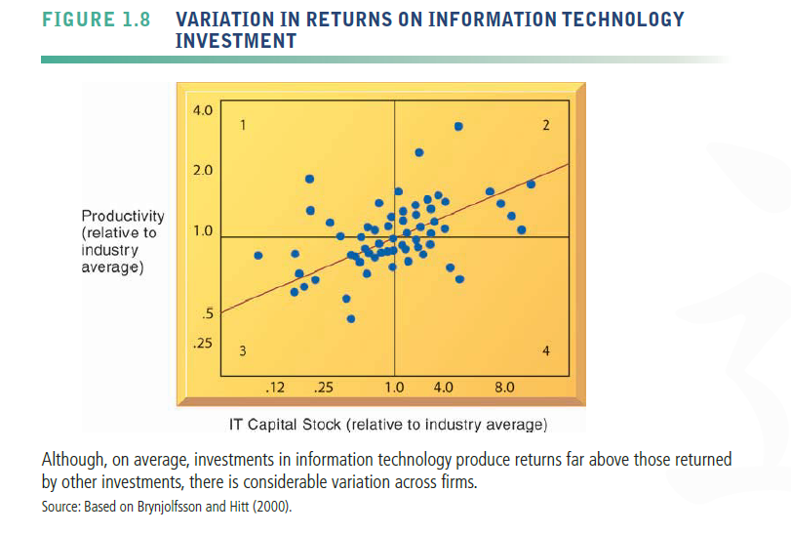

* Complementary assets include

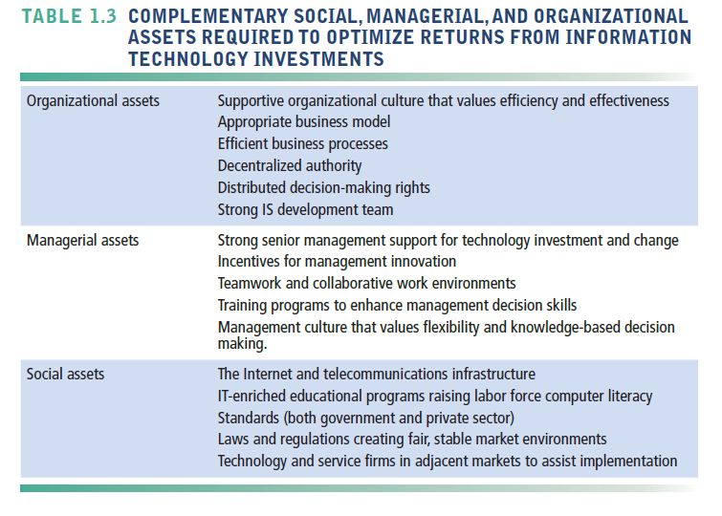

1. CONTEMPORARY APPROACHES TO INFORMATION SYSTEMS
   * Preface

* The study of information systems is a multidisciplinary field
* Divide into technical and behavioral approaches.
* Information systems are sociotechnical systems.

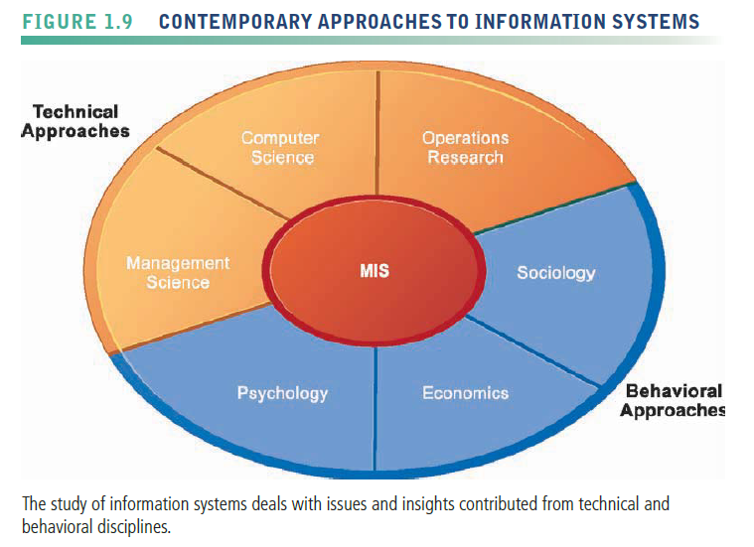

* + Technical approach
* mathematically based models to study information systems, as well as the physical technology and formal capabilities of these systems.
* Computer science, management science, operations research
  + Behavioral approach
* concentrates on changes in attitudes, management and organizational policy, and behavior.
* Behavioral issues (strategic business integration, implementation, etc.)
* Psychology, economics, sociology
  + Approach of This Text: Sociotechnical Systems
* management information systems (MIS)
* Combines computer science, management science, operations research, and practical orientation with behavioral issues
* Concern with behavioral issues surrounding the development, use, and impact of information systems, which are typically discussed in the fields of sociology, economics, and psychology.
* Four main actors
* Suppliers of hardware and software
* Business firms
* Managers and employees
* Firm’s environment (legal, social, cultural context
  + - * + Together these actors produce what we call management information systems .
* Approach of this book: Sociotechnical view
* Optimal organizational performance achieved by jointly optimizing both social and technical systems used in production
* Helps avoid purely technological approach

